Final Project UW Boot Camp

Sonmi Kim

Role : Square

NOTE: Sample is often wrong because of initial testing was done

**STEP 1: Clean / Visualizing – Using Jupiter notebook**

Sample data segment:

Real data segment to run a model : input of vehicle ID expected from front end

NOTE: Vehicle id represents unique vehicle in the full table, dropped make model here

Sample data description :

Real Data Description:

Sample Data correlation:

Sample data correlation diagram:

Real Data Correlation diagram:

Sample data graph

Real data graph

Sample data scattering:

Real data scattering:

**STEP 2 : Modeling – Using Colab**

**X-TRA – visual – Colab trying to visualize Real data**

Attempted to describe why the sample data is more effective to visualize than the real data, it is important to know that it is impossible to distinguish data from the diagrams that I attempted, although EDCF (Empirical Distribution Function ) seems a little better than others, I stopped attempting to see further. – This was part of the test BTW

**MODELING :**

Logistic Regression Multiple Classes

* The variation of the credit score can be a lot. However, in the big picture, it can be categorized as a bunch of classes
* When Logistic Regression is used, it can predict like hand-written digits or sport, politics, stocks, etc.
* formular -> f(x:w) = 1/1+e**-w**t*x
* Used sigmoid

I Can’t run the Model with full data – not capable of it. RAM crash

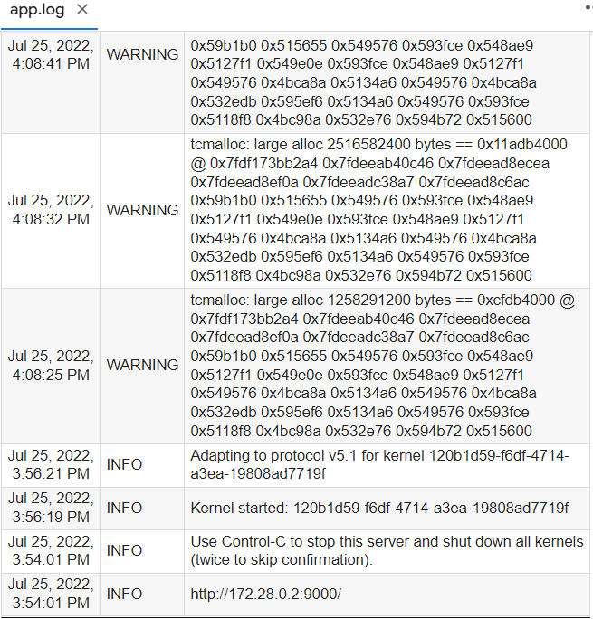

**First 1000:**

**RandomForestClassifier:**

**KNN:**

**First 5000:**

First 10,000:

